Parth Gandhi, Z1807278

Juan Alvarado, Z1782029

OMIS 452 Sec:1

5/9/17

P.6

1.

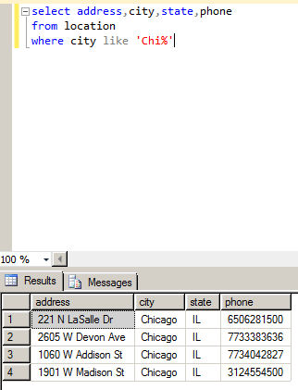

Explanation: My business will use this query to find address, city, state and phone number of our business operations which are located in city whose first three letter starts with ‘Chi’. Since my business operates in lot of other states, this will help me narrow down cities where my business operation is located.

2.

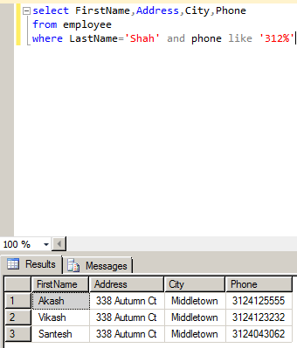

Explanation: The H.R Department of my business will use this query to figure out whether these three employees with same last name, address, city, and similar phone area code are related to each other, and if they are related to each other whether they can become each other emergency contact person.

3.

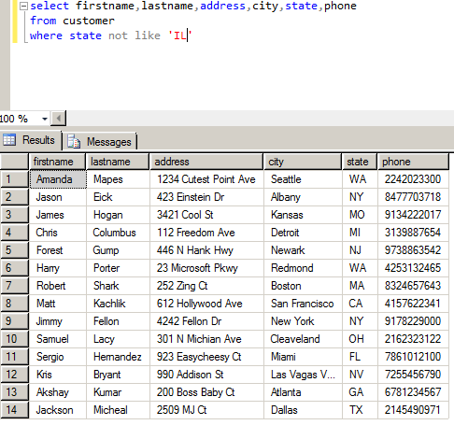

Explanation: My business will use this query to find out how many other customers we have who are not from state of Illinois, with their first and last name, address, city, state and phone so we can send promotion flyers, such as new game, sales and discount going on games, to them other than sending the promotion flyers to customers from Illinois.

4.

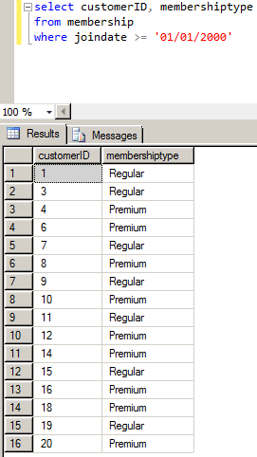

Explanation: My business will use this query to figure out which membership type is popular amongst customers who became member of the company after 1st Jan. 2000, so we can decide our business strategy of whether to add new features in current membership type, introduce new membership type or keep the two-membership type as they are, to attract new customers in future.

5.

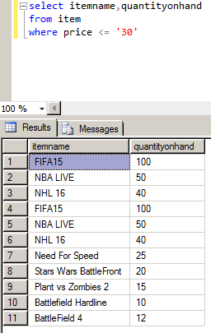

Explanation: My company employee will use this query to find which games falls under $30 and check the inventory of games the store currently have. Using this query my employee will help better assist a customer, who wants to buy a game that falls under his budget of $30, and check if the games under the price range is available or not.

6. 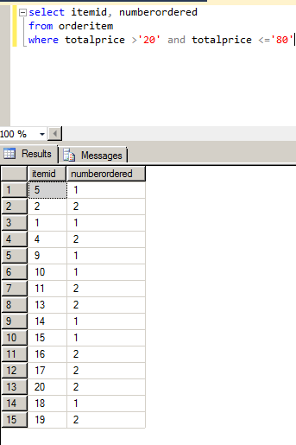

Explanation: The business will use this query to find which item is more popular between minimum total price and maximum total price. Item ID is linked to specific game so we can use Item ID to give out order to produce more copies of games for our budget focused customers.

7.

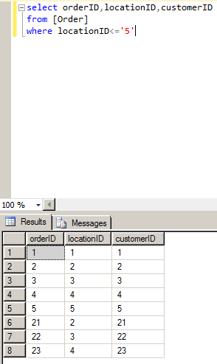

Explanation: The business will use this query to ship the orders of the customers to location they were ordered from, so customers do not have pay for shipping cost and customers can directly pickup from location they ordered from.

8.

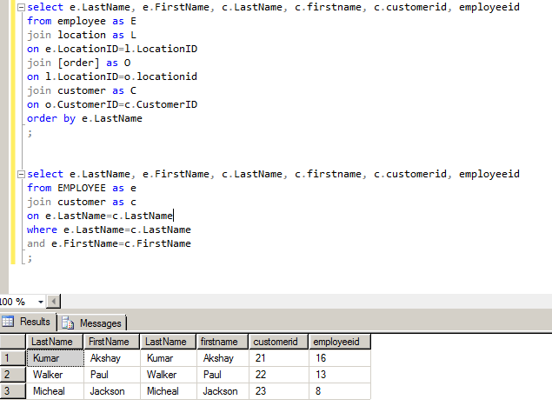

Explanation: My business is going to use this query to find employees first name, last name and employee ID by matching employee first name and last name with my customers first name and last name so we can offer extra discount to those employees to appreciate them for being our customers and working hard to make better products for company.